PvSubnet1

PvSubnet2

PvSubnet3

PvSubnet4

PbSubnet1

PbSubnet2

PbSubnet3

PbSubnet4

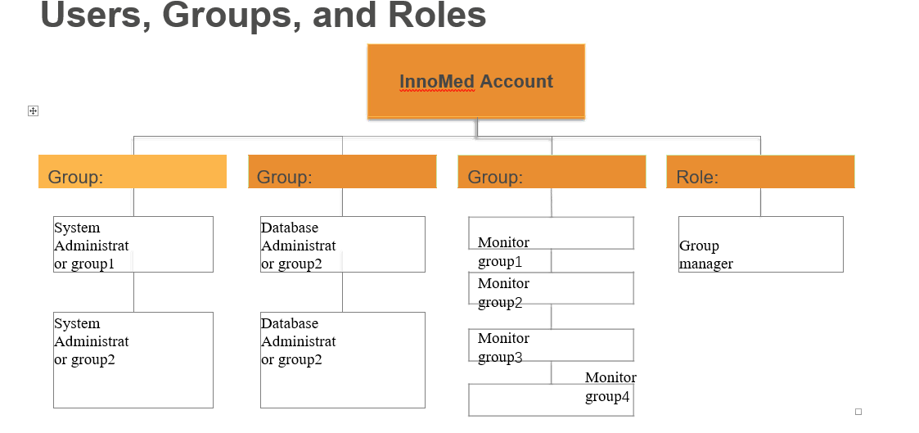

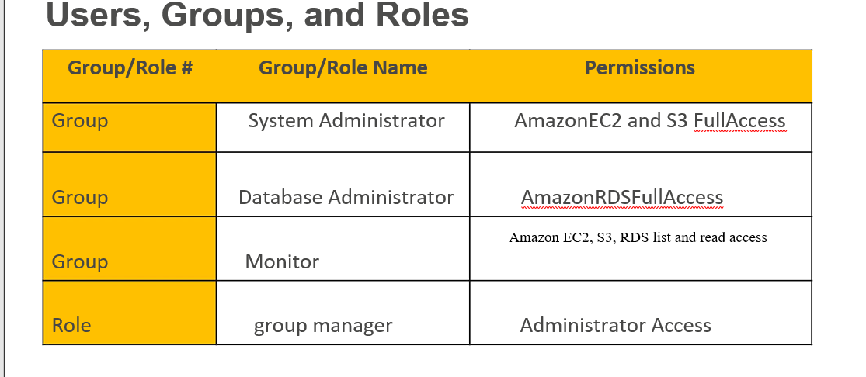

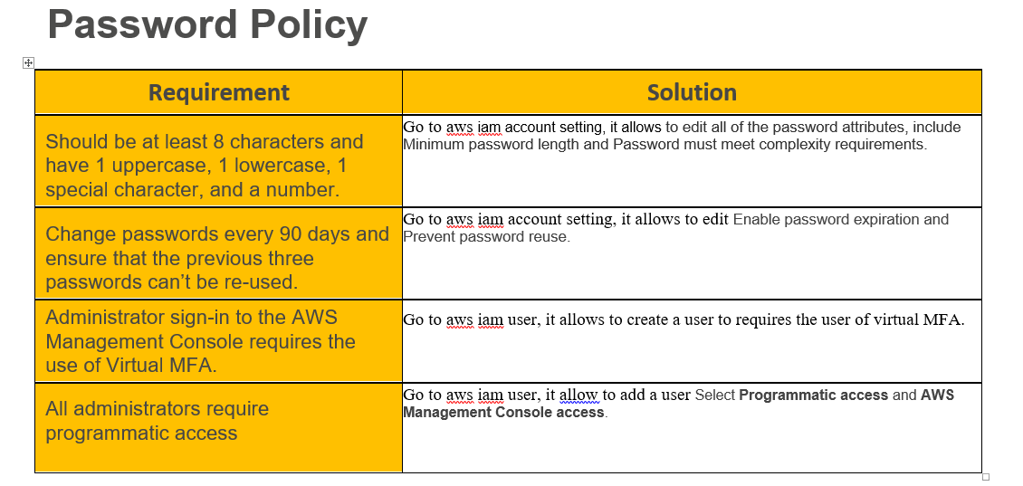

**VPC Details**

|  |  |  |  |  |  |
| --- | --- | --- | --- | --- | --- |
| VPC | REGION | PURPOSE | SUBNETS | AZS | CIDR RANGE |
| vpc-ces33er | Ireland | Enable to launch AWS resources into a virtual network that we’ve defined | 5 private subnets  3 public subnets | 2 availability zones | 10.0.0.0/16 |

**Production Subnet Detail**

|  |  |  |  |  |
| --- | --- | --- | --- | --- |
| Subnet name | VPC | SUBNET TYPE | AZ | SUBNET ADDRESS |
| publicSubnet1 | vpc-ces33er | Public | AZ1 | 10.0.0.0/24 |
| DbSubnet1 | vpc-ces33er | Private | AZ1 | 10.0.1.0/24 |
| webSubnet | vpc-ces33er | Public | AZ1 | 10.0.2.0/24 |
| AdmSubnet1 | vpc-ces33er | Private | AZ1 | 10.0.3.0/24 |
| publicSubnet2 | vpc-ces33er | Public | AZ2 | 10.0.4.0/24 |
| DbSubnet2 | vpc-ces33er | Private | AZ2 | 10.0.5.0/24 |
| appSubnet | vpc-ces33er | Public | AZ2 | 10.0.6.0/24 |
| admSubnet2 | vpc-ces33er | Private | AZ2 | 10.0.7.0/24 |

**Instance Detail**

Tier: Web

Tag*: Key = Name, Value = web-tier

OS：Microsoft Windows Server 2016 with NVIDIA GRID Driver

Type: c5d.large

Size: 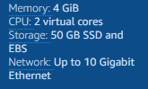

Justification: As required 4gb memory , 2 cpu and Microsoft Windows 2016 Base with IIS.

#of instances: 1

User Data?:

Tier: App

Tag*: Key = Name, Value = app-tier

OS：IBM WebSphere Application Server Base Edition v 8.5 on Windows

Type: t2.xlarge

Size: 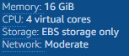

Justification: As required 8gb memory , 4 cpu and Microsoft Windows 2016 Base with IIS.

#of instances: 1

User Data?:

Tier: DB

Tag*: Key = Name, Value = db-tier

OS：CIS Microsoft Windows Server 2016 Benchmark Level 1

Type: d2.xlarge

Size: 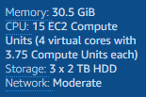

Justification: close to required 32gb memory, 8 cpu, 5tb storage and Microsoft Windows 2016 Base with IIS.

#of instances: 1

User Data?:

**Load Balancer and Instance Security Group Detail**

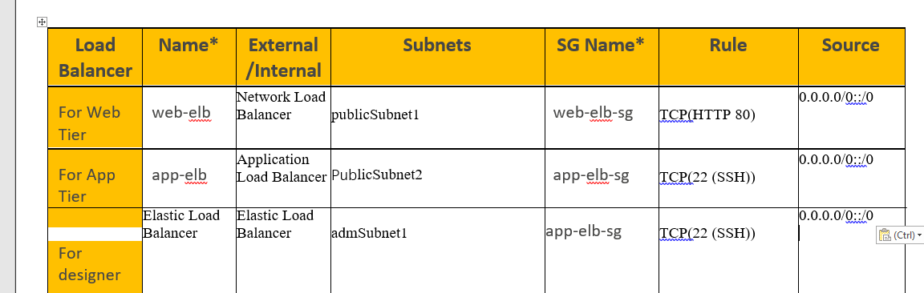

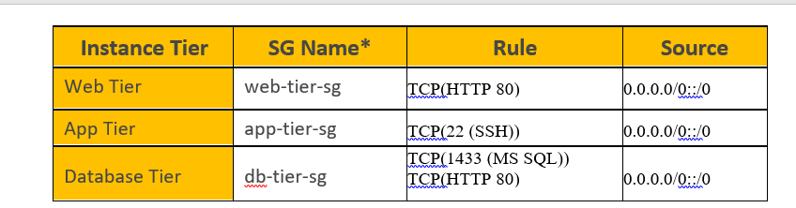

**Auto Scaling Launch Configuration**

|  |  |  |  |  |  |  |
| --- | --- | --- | --- | --- | --- | --- |
| Tier | OS | Type | Size | Configuration  Name* | Role | Security  Group |
| Web | Microsoft Windows Server 2016 with NVIDIA GRID Driver | c5d.large |  | WebTier | Create virtual web services | web-tier-sg |
| App | IBM WebSphere Application Server Base Edition v 8.5 on Windows | t2.xlarge |  | AppTier | Create virtual application | app-tier-sg |

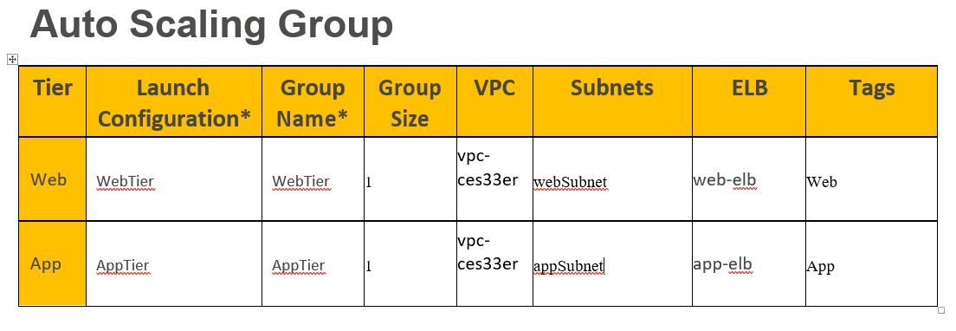

How do you configure an account to create an audit trail for allexecuted API calls?

Use CloudTrail and CloudWatch Events to monitor API calls

**Q**. Where do you save your logs?

I will save my log in Amazon CloudWatch Logs.

